**Exercise 4**

Make a commit, and make a silly typo in the commit message.

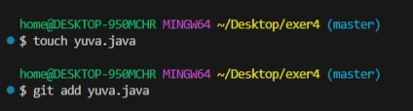

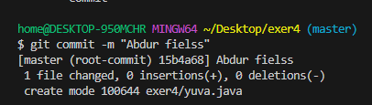

Use the **--amend** flag to enable you to fix the commit message.

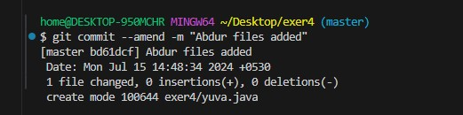

Look at the **log** and notice how the mistake is magically gone.

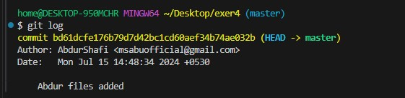

Now make a commit where you make a typo in one of the files. Once again, use **--amend** to magic away your problems.

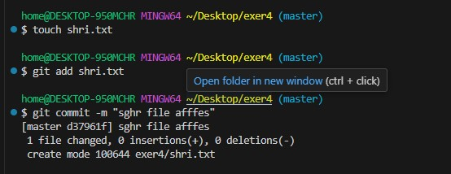

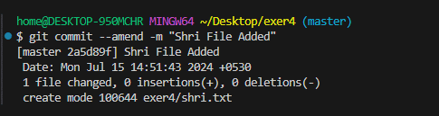

Create a branch. Make a commit.

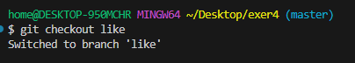

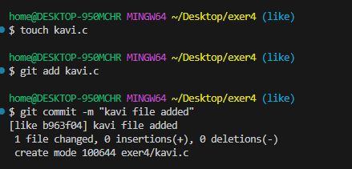

Now switch back to your master branch. Make a (non-conflicting) commit there also.

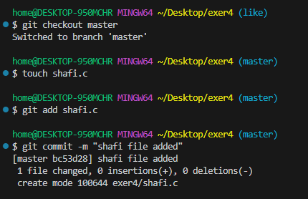

Now switch back to your branch.

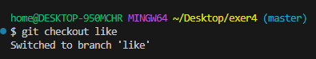

Use the **rebase** command in your branch

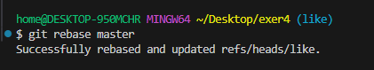

Look at the DAG in **gitk**, and note that you have the commit from the master branch, but no merge commit



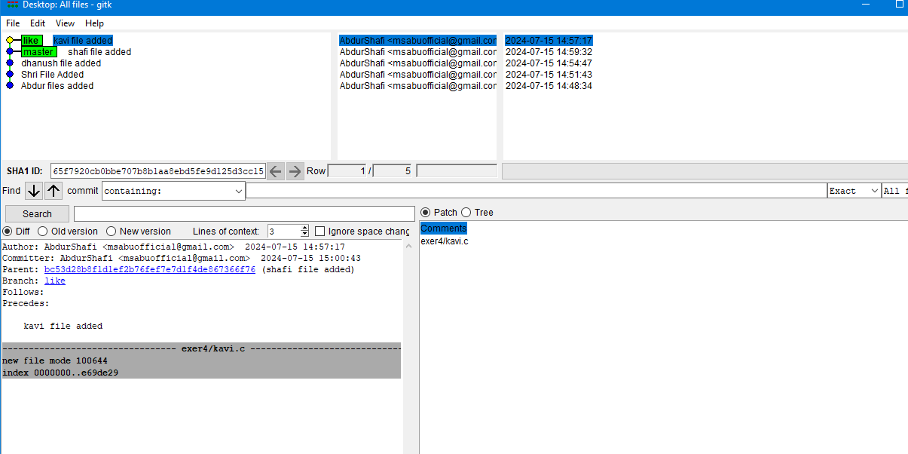

Make one more commit in your branch.

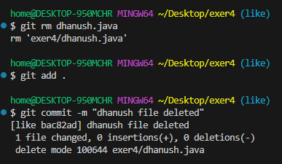

Return to master. Merge your branch.

